Godaddy Github hosting

1) SS of godaddy DNS panel

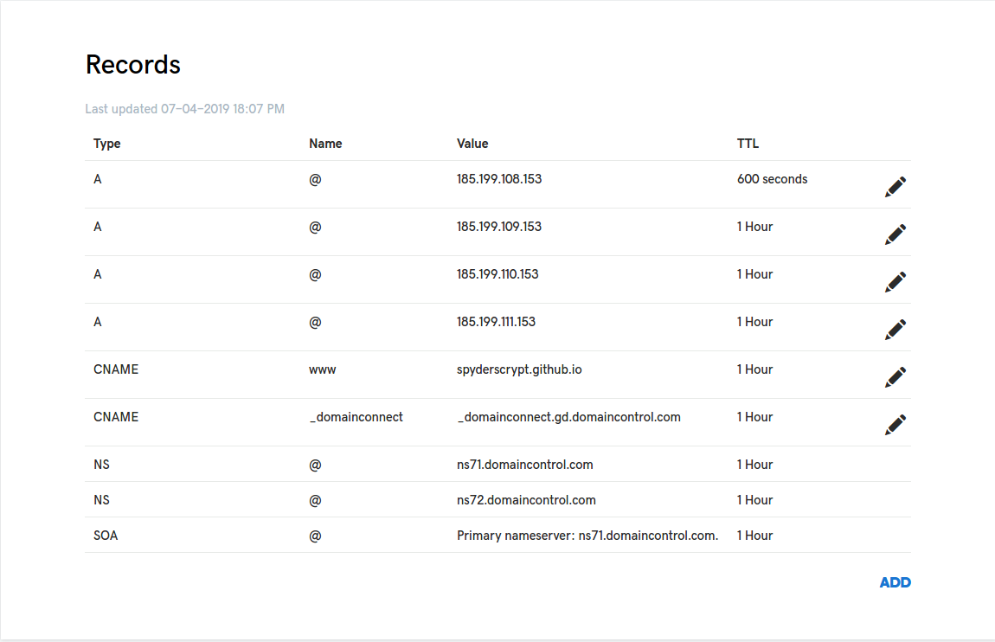

Note the CNAME herer , it is spyderscrypt.github.io

2) Github repo SS

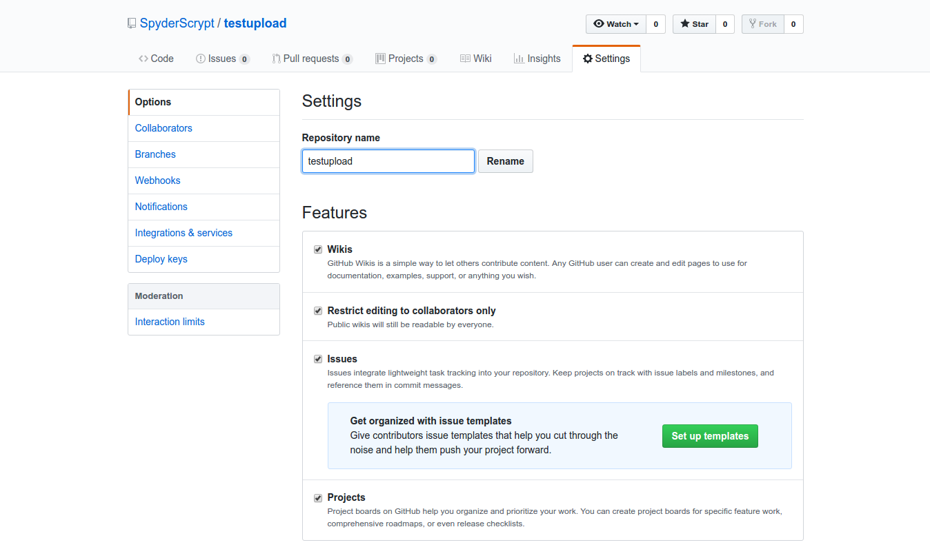

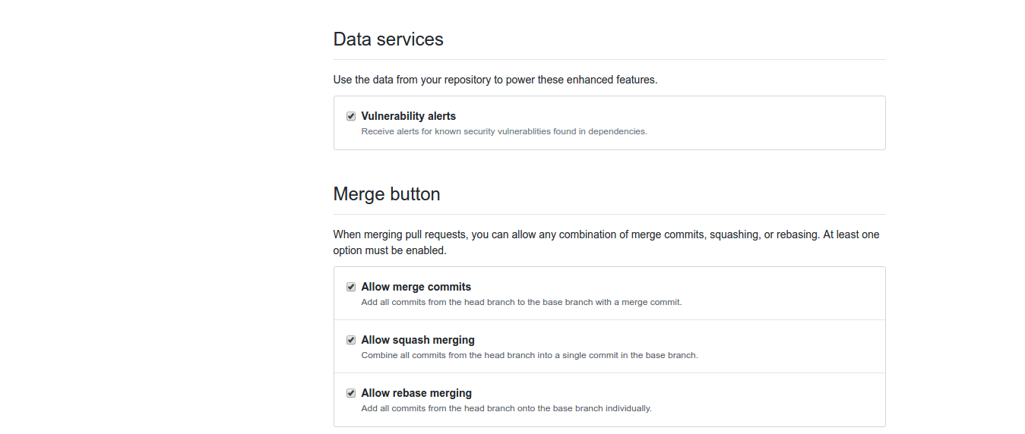

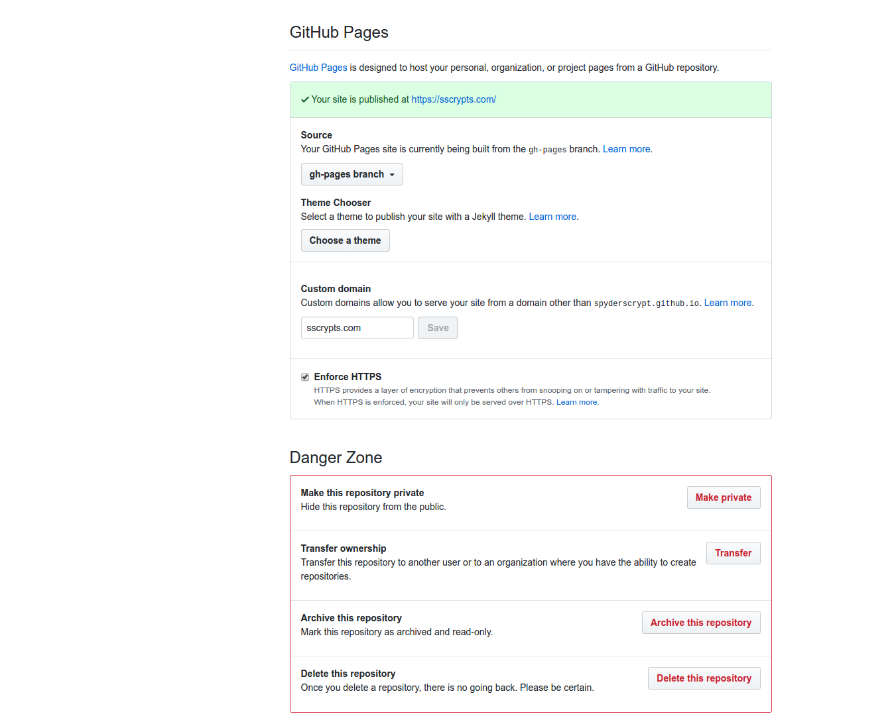

3) CNAME file in root
put CNAME file in root (not .CNAME only CNAME)
contents -
sscrypts.com
www.sscrypts.com

4) Package.json
{
"name": "sscryptwebsite",
"version": "0.1.0",
"private": true,
"homepage": "https://sscrypts.com",
"dependencies": {
"font-awesome": "^4.7.0",
"gh-pages": "^2.0.1",
"react": "^16.8.6",
"react-dom": "^16.8.6",
"react-instagram-embed": "^1.5.0",
"react-particles-js": "^2.5.1",
"react-router-dom": "^5.0.0",
"react-scripts": "2.1.8"
},
"scripts": {
"start": "react-scripts start",
"build": "react-scripts build",
"test": "react-scripts test",
"predeploy": "npm run build",
"deploy": "gh-pages -d build",
"eject": "react-scripts eject"
},
"eslintConfig": {
"extends": "react-app"
},
"browserslist": [
">0.2%",
"not dead",
"not ie <= 11",
"not op_mini all"
]
}

5) Make changes and push
1- First make changes and push it
2 – npm run predeploy
3 – npm run deploy
4 – goto github repo -> ghpages branch and check if commit has happened then , in settings put custom domain sscrypts.com

